**FRONT END WEB DEVELOPMENT**

**PROJECT NAME:** FAIR PLAY ( E-commerce sports shop)

**DESCRIPTION :**

Based on the problem statement given to us we have planned to design a web page for sports requirements and we have named our shop as

*Outline:*

* Home page
* Products
* About us
* Contact us

HOME PAGE:

Home page is basically divided into four sections header banner content and footer these contents are given by HTML and the styles are given using CSS.

* Our home page is designed with our shop logo at the top left corner we have used <img> tag, then product details, contact details, shop details links are given by <ul> tag at the top right corner. These comes under header section by using <div> tag.
* In the banner section we display our shops stunning images and product images with affordable prices and offer, we have used <img> tag for displaying images and using CSS we styled these images. These images are given in the link form”(<a href> tag using css we styled these letters eg(font-size,font-color)) and if we click on to that it will direct you to the products page this product page link is given in <a href>as external link which shows you about the detailed description about the product.
* Then followed by the content section which consist of three blocks. These blocks are given using<div>tag. In the first block there will be a stunning sports equipment images (<img> tag is used and using CSS we styled that) and there will a sentence given as ”A huge collection of sports equipment’s”(<a href> tag using css we styled these letters eg(font-size,font-color)) if we click on to that it will direct you to the product page(external link) which contains all the sports items.
* In the second block there will be a stunning sportswear images(<img> tag and styled using css) and there will a sentence given as ”A huge collection of sportswear for men and women” ” ”(<a href> tag using css we styled these letters eg(font-size,font-color)) if we click on to that it will direct you to the product page(external link) which contains all the sportwear.
* In the third block there will be a stunning sportswear images(<img>tag and styled using css) and there will a sentence given as” Looking for hiking boots, walking shoes, sandals or outdoor wear? Choose from a large range today.” ”(<a href> tag using css we styled these letters eg(font-size,font-color)) if we click on to that it will direct you to the product page which contains all the shoes accessories.
* Then followed by the bottom section. This bottom section is made by using <div> section.In the left side of the bottom section our best branded products images (<img>tagand styled using css) will be displayed and at the right side of that section we will provide our customized service where we will offer warranty at limited time.
* Then below that we will add slider in which different brands are displayed where you can choose your respective brand and if we click on that it will take you to that page.
* Then followed by footer section. In that we will provide lots of information for users like contact details, our shop details, payment details and suggestion box (<ul> tag )where the user can ask for any queries.

**FIGMA MODEL HOME PAGE:**

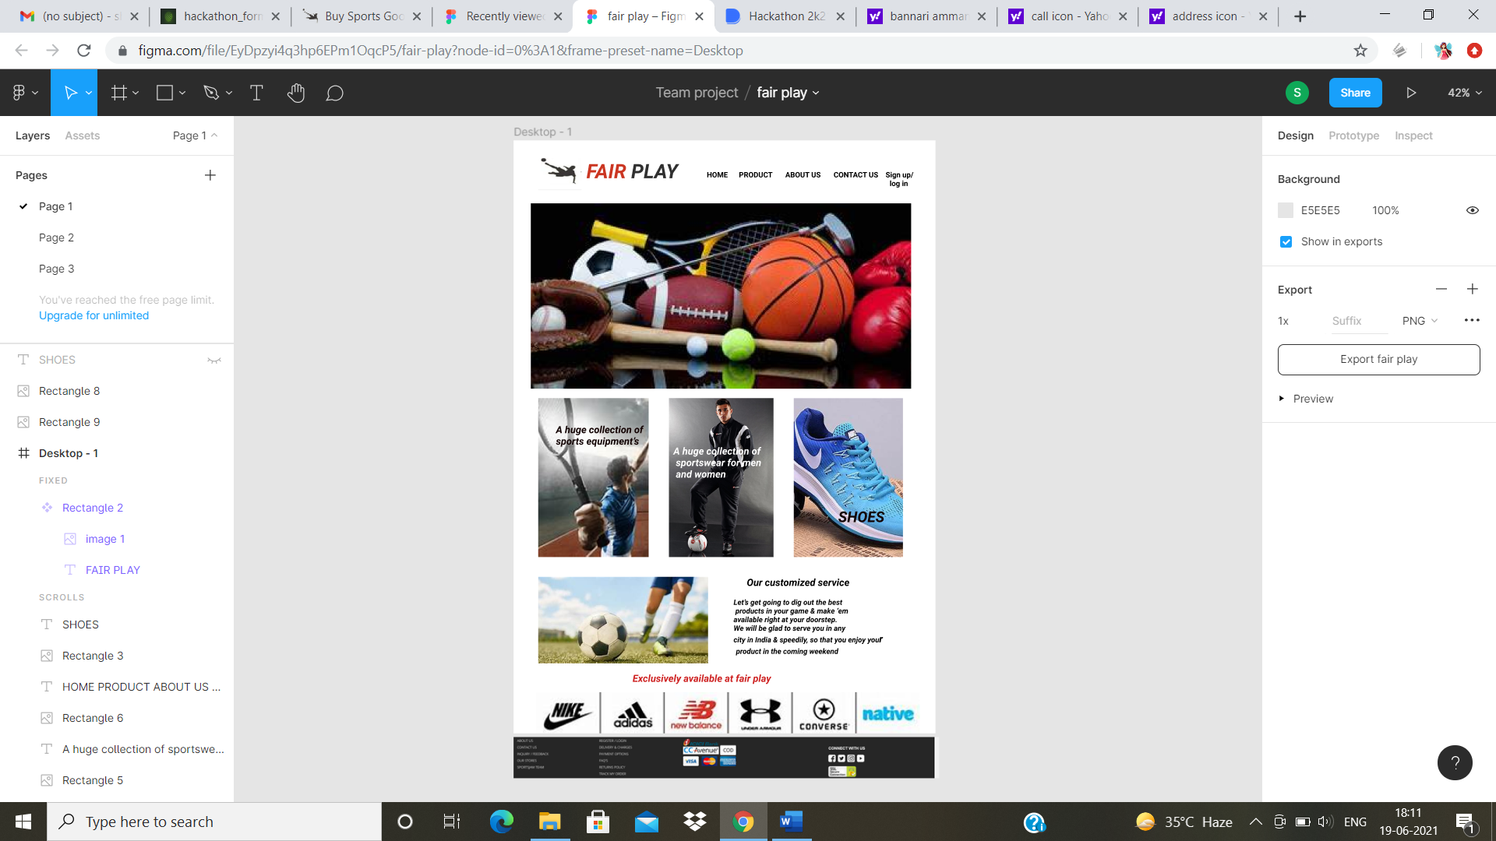

PRODUCT PAGE:

* This page is designed using HTML,CSS,JAVASCRIPT.
* In the centre of the header(<div>) section search bar is placed where you can choose and purchase your desirable products.
* Now we will explain about the detailed description about our products page .

For example:

* If the person wish to purchase the shoes, then he randomly goes in search of the branded items. Then he will get the list of shoes as a catalogue.
* For his better understanding the catalogue will provide the clear picture of the items and the price with ratings and offers then at the left side there will a block that displays category menu where the sports accessories ,costumes, shoes will be displayed. Below that he will get one more block where the brands of the selected category will be displayed where he can choose the product that he wish.
* Then finally when he gets attract to one of the shoes he clicks on to that, then he gets the full detail about that product. Going deep into the product page gives him deep information like price, offer, ratings, size and various colors of that item. To check the shipping availability of the product you will be provided with a checkbox where you can enter your pincode and verify your availability .
* If he wants to know about the quality and specialisation about the shoes he can scroll down to check the review and ratings of the particular product . If he likes that product he can keep that under the wish list category and buy it later or if he wants to buy that immediately he can click on to the add to cart option and then he can buy.

**FIGMA MODEL PRODUCT PAGE:**

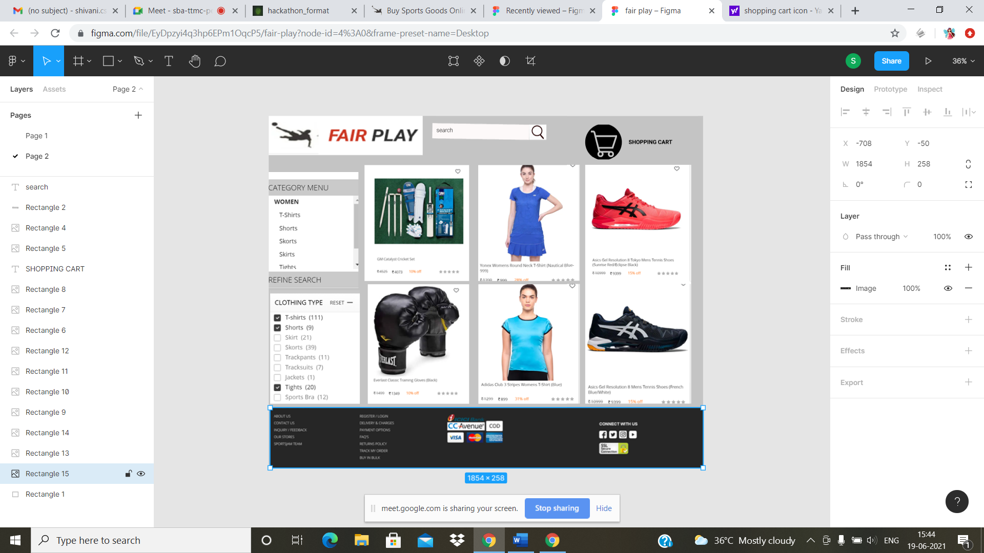

About us:

This page is designed using HTML,CSS,JAVASCRIPT. In the home page you will find shop details link at the top right corner which will take you to our shop details page or about us page(using external link <a href>). In that page you will find our shop images and details about our fair play(shop name). You will find the good and satisfying reviews about our shop and lakhs++++ happy customer.

**FIGMA MODEL ABOUT US PAGE:**

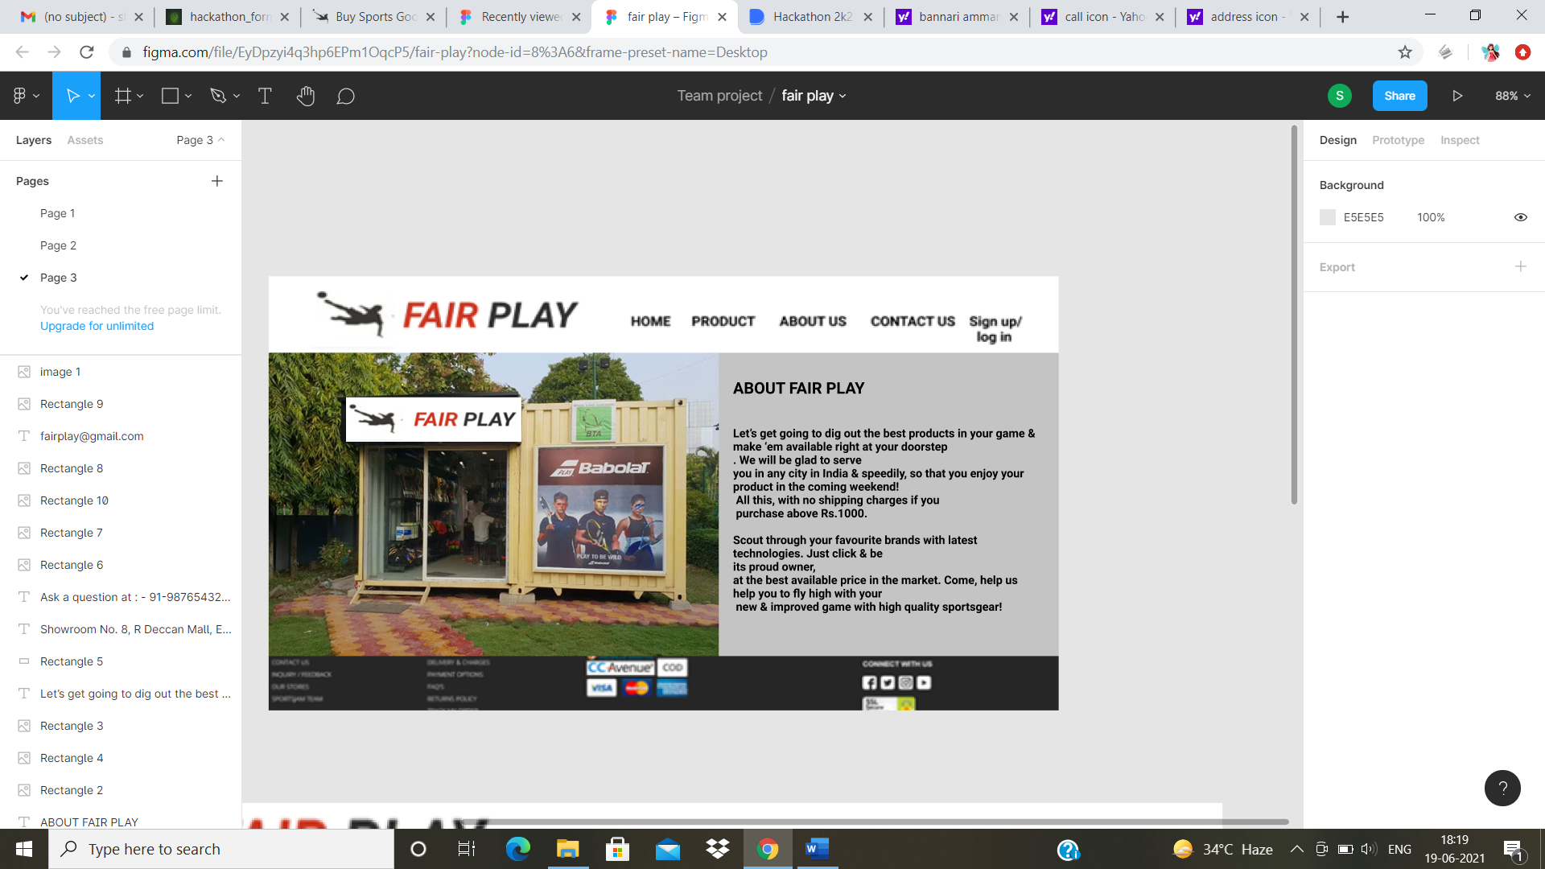

**Contact** **Us**:

This is designed using HTML, CSS, JAVASCRIPT. In the home page you will find contact us at the top right corner which will take you to the contact us page(using external link <a href> tag is used).In the contact us page you will find the contact details, email, our shop address .Then links of our social media accounts are given below so that you can get the updates and new arrival of our shop.

**FIGMA MODEL CONTACT US PAGE:**

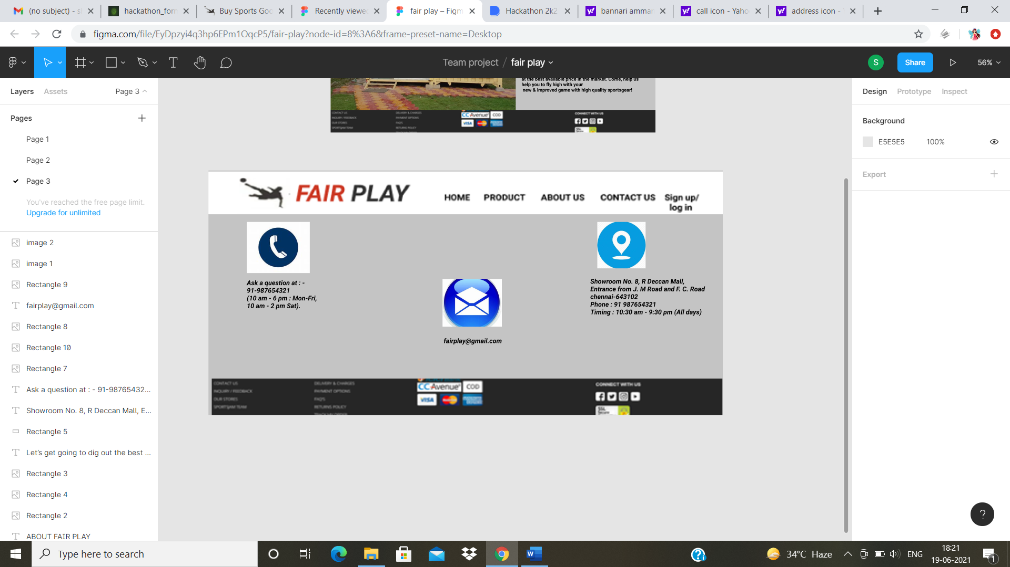

**The problem it solve :**

* The major problem faced by many customers is that they have many queries regarding that particular item so inorder to satisfy their needs we have provided every details properly. For example: availabilty of the products,size and rate, quantity of stocks.
* If a person wish to buy something that person wish that the product should fit him properly because the unsized item make him uncomfortable .For solving this we have provided a check box where he can choose his perfect size .
* If supose the customer is not satisfied with the color or design he can return the product within two days.

**TECHNOLOGIES USED:**

* HTML
* CSS
* JAVA SCRIPT
* XAMPP
* PHP.